ONEWAY CS BY Gender1
/STATISTICS DESCRIPTIVES HOMOGENEITY WELCH
/PLOT MEANS
/MISSING ANALYSIS.

Oneway

Notes
Output Created |  | 05-May-2019 23:07:54
Comments
Input | Active Dataset | DataSet0
Input | Filter | <none>
Input | Weight | <none>
Input | Split File | <none>
Input | N of Rows in Working Data File | 30
Missing Value Handling | Definition of Missing | User-defined missing values are treated as missing.
Missing Value Handling | Cases Used | Statistics for each analysis are based on cases with no missing data for any variable in the analysis.
Syntax |  | ONEWAY CS BY Gender1  /STATISTICS DESCRIPTIVES HOMOGENEITY WELCH  /PLOT MEANS  /MISSING ANALYSIS.
Resources | Processor Time | 00 00:00:00.203
Resources | Elapsed Time | 00 00:00:00.179

[DataSet0]

Descriptives
 | N | Mean | Std. Deviation | Std. Error | 95% Confidence Interval for Mean
 |  |  |  |  | Lower Bound | Upper Bound
Female | 6 | 35.3333 | 4.54606 | 1.85592 | 30.5625 | 40.1041
Male | 24 | 39.1667 | 1.94862 | .39776 | 38.3438 | 39.9895
Total | 30 | 38.4000 | 3.00115 | .54793 | 37.2794 | 39.5206

Descriptives
 | Minimum | Maximum
Female | 28.00 | 40.00
Male | 34.00 | 40.00
Total | 28.00 | 40.00

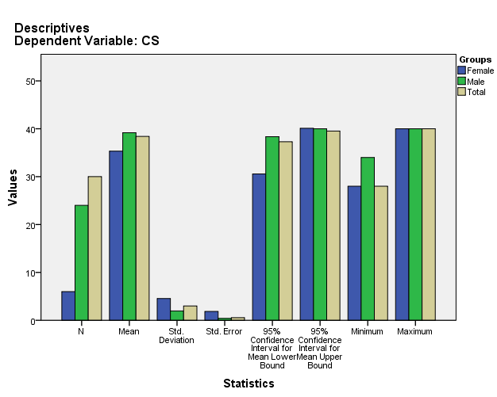

Test of Homogeneity of Variances
CS
Levene Statistic | df1 | df2 | Sig.
6.540 | 1 | 28 | .016

ANOVA
CS
 | Sum of Squares | df | Mean Square | F | Sig.
Between Groups | 70.533 | 1 | 70.533 | 10.358 | .003
Within Groups | 190.667 | 28 | 6.810
Total | 261.200 | 29

Robust Tests of Equality of Means
CS
 | Statisticª | df1 | df2 | Sig.
Welch | 4.079 | 1 | 5.467 | .095
a. Asymptotically F distributed.

Means Plots

